Problem 2

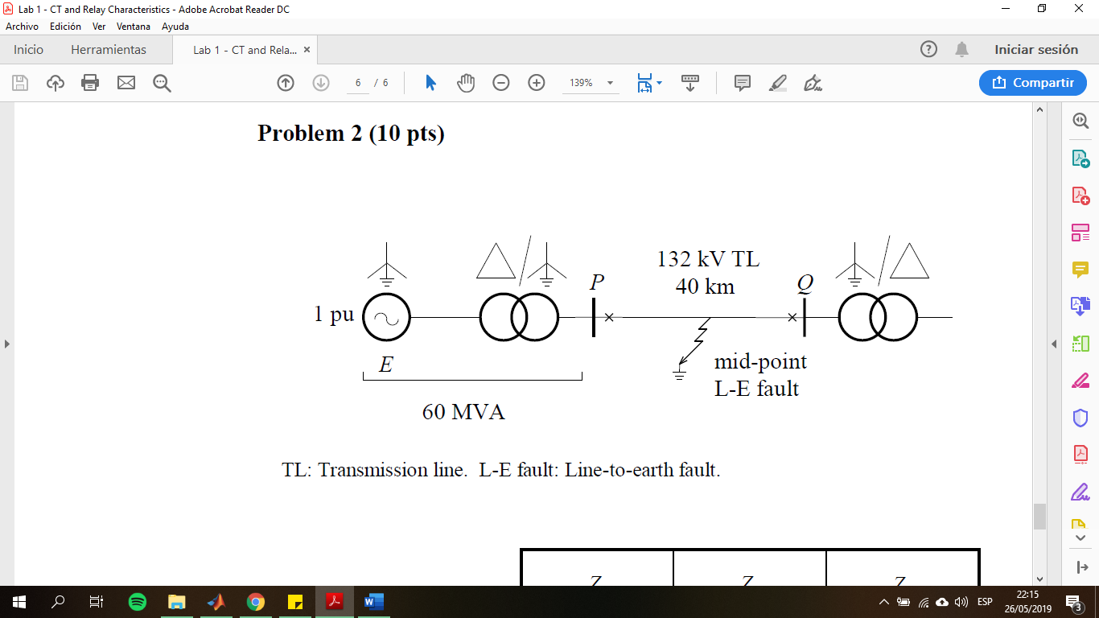

Figure 1. System of study.

For a monophasic fault, the system analyzed from its sequence is shown in the following figure:

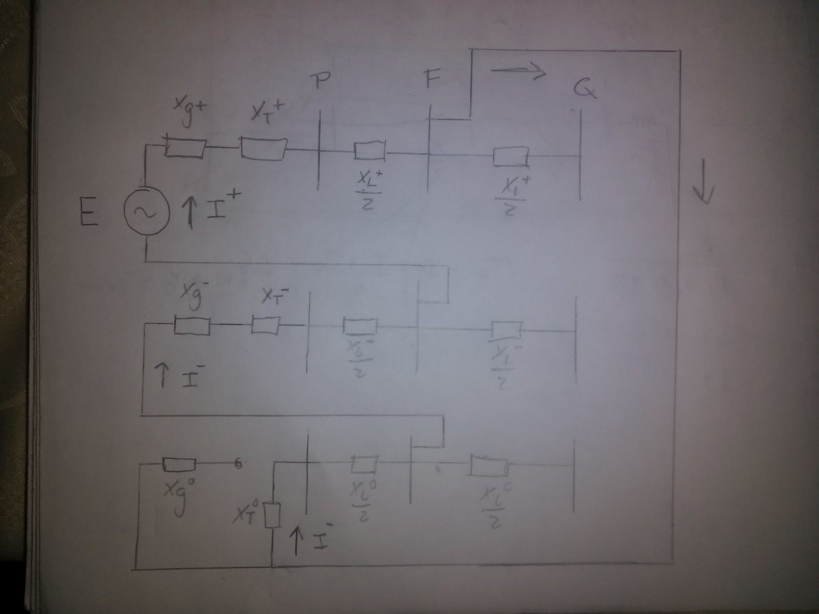

Figure 2. Diagram of sequences.

The sequences for a monophasic fault are connected in series. Note that since the fault occurs at the midpoint of the transmission line, only half of the line impedance is taken in count. Also, since the transformer is connected in delta, in the zero sequence the delta connection is an open circuit between the generator and the transformer.

Since the sequences are connected in series, all the sequence currents are equal. The positive sequence current is calculated as:

$$I_{+}=\frac{E}{Z_{+}+Z_{-}+Z_{0}}$$

The sequence impedances are the equivalent impedances present in each if the sequence circuits. These are calculated as:

$$Z_{+}=Z_{g+}+Z_{t+}+\frac{Z_{l+}}{2}=0.2482$$

$$Z_{-}=Z_{g- }+Z_{t-}+\frac{Z_{l-}}{2}=0.2182$$

$$Z_{0}=Z_{t0}+\frac{Z_{l0}}{2}=0.2205$$

Then:

$$I_{+}=\frac{1.0∠0}{0.5869}=1.4557$$

Since $I_{-}=I_{0}=I_{+}$, the phase-a fault current is:

$$I_{a}=I_{+}+I_{-}+I_{0}=3I_{+}=4.3672 p.u=1146.1 kA$$

Since the sequences are in series, the current at point P is

$$I_{p}=I_{a}=4.3672 p.u=1146.1 kA$$

The voltage at point P can be calculated as:

$$Vp_{a}=E-\left(Z_{g+}+Z_{t+}\right)I_{+}=0.7089=93.57 kV$$

The impedance seen from point P can be calculated from the above expression as:

$$Vp_{a}=E-\left(Z_{g+}+Z_{t+}\right)I_{+}=E-\frac{\left(Z_{g+}+Z_{t+}\right)E}{Z_{+}+Z_{-}+Z_{0}}$$

$$Vp_{a}=E\left[\frac{Z_{+}+Z_{-}+Z_{0}-Z_{g+}-Z_{t+}}{Z_{+}+Z_{-}+Z_{0}}\right]=E\left[\frac{Z_{-}+Z_{0}}{Z_{+}+Z_{-}+Z_{0}}\right]$$

Then:

$$Zp_{a}=\frac{Vp_{a}}{I_{a}}=E\left[\frac{Z_{-}+Z_{0}}{Z_{+}+Z_{-}+Z_{0}}\right]*\left[\frac{Z_{+}+Z_{-}+Z_{0}}{3E}\right]=\frac{Z_{-}+Z_{0}}{3}$$